Pike Lake
Lake ID# 69-0490-00
2012-2013 CLMP+ Data Summary

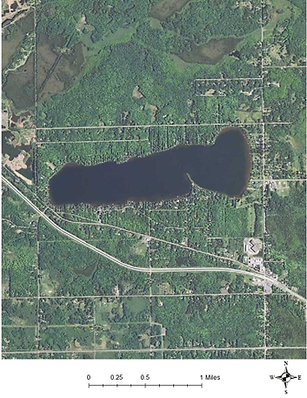
Introduction
Numbers shown are summer mean values (June – September)

The Minnesota Pollution Control Agency (MPCA) conducts and supports lake monitoring activities to determine if water quality supports recreational uses (swimming, wading, boating, etc.) of lakes, and to measure and compare regional differences and trends in water quality with lakes from all over the state. MPCA staff, local partners (SWCDs, watershed districts, tribal entities, etc.), and citizens all play a role in sampling lake water quality.
Site 102

As part of the MPCA’s Advanced Citizen Lake Monitoring Program (CLMP+), Brian Mirsch and Mark Rauschenfels measured water quality at Site 102 in Pike Lake from May-September in 2012 & 2013. Pike Lake is located in St. Louis County, approximately 10 miles northwest of Duluth, Minnesota. It is 482 acres in size, has a maximum depth of 18 meters (60 feet), and a mean depth of 8 meters (26 feet). CLMP+ volunteers measured water transparency, collected temperature and dissolved oxygen profiles weekly, and collected water chemistry samples monthly. This report provides a summary of the water quality data, and of other physical and ecological characteristics, of the lake (Figures 1 and 2).
Figure 1. Aerial photo of Pike Lake

Ecoregion and Land Use Characteristics
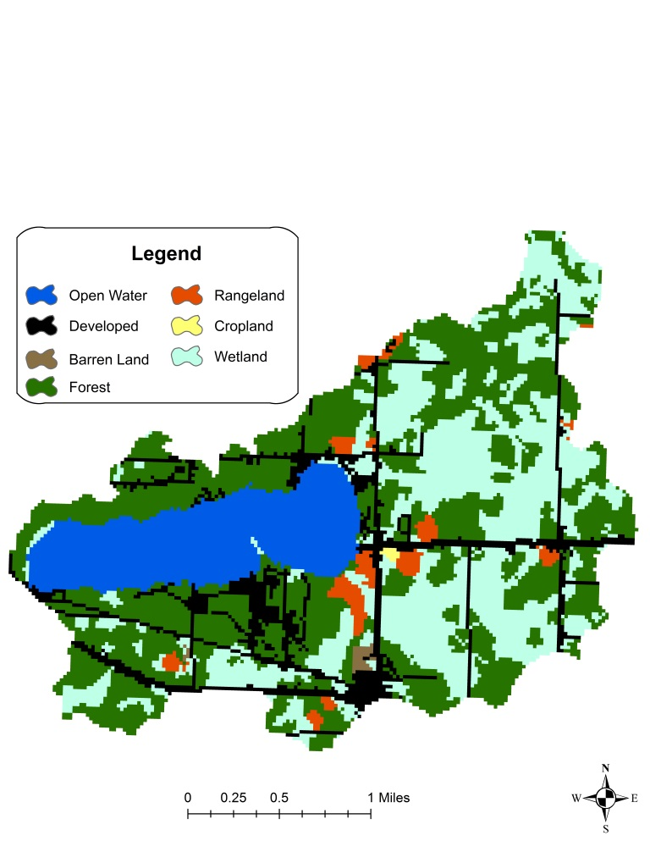When investigating lake water quality, it is important to consider how land within the lake’s catchment (the area of land surrounding the lake that drains water directly to it) is used. Certain uses of the land increase pollutant loading to the lake. For instance, phosphorus in animal waste can runoff from feedlots to surface waters during heavy rain events. Likewise, manure and commercial fertilizers can be washed from cultivated fields over land or through tiling systems to lakes. Additionally, phosphorus binds tightly to soil, so eroded soil from developed lakeshore or stream banks is often a large source of phosphorus to lakes and streams. Conversely, forested areas, undeveloped land, and wetlands are important features that preserve good water quality by serving as a buffer to filter water that flows across the catchment and into the lake.
Figure 2. Pike Lake catchment land use
Minnesota is divided into seven ecoregions, as defined by soils, land surface form, natural vegetation and current land use. Pike Lake is located in the Northern Lakes and Forests (NLF) ecoregion. Throughout this report, Pike Lake characteristics are compared to the typical range of values from reference lakes within the NLF ecoregion. Pike Lake has a catchment area of 3,380 acres. This is a medium-sized watershed relative to the size of the lake (7:1 watershed: lake area ratio). Lakes with small-medium watersheds relative to lake area often receive low water loads; in contrast, those with large watersheds often receive high water loads. The amount of nutrients present within the water load for any size lake depends greatly upon land use in the larger watershed. In general, land use in the Pike Lake catchment is similar to the typical land uses found in the NLF ecoregion (Table 1), with more development and open water/wetland areas and slightly less forested land than the typical NLF area. Pike Lake’s watershed is dominated by forest and wetland, which typically deliver low amounts of nutrients to nearby lakes (Figure 2).A sewer system was constructed around Pike Lake in 1999 in an effort to improve water quality and zebra mussels were discovered on the lake in 2009.

Table 1. Land use composition
Land use | Pike Lake catchment land use percentage | NLF typical land use percentage
Developed | 12 | 0 – 7
Cultivated (Ag) | 0 | < 1
Pasture & Open | 3 | 0 – 6
Forest | 41 | 54 – 81
Water & Wetland | 44 | 14 – 31
Feedlots (#) | 0

Lake Mixing and Stratification

Lake size, depth and the shape of the basin, affect whether a lake stratifies (forms distinct temperature layers) and how it mixes, which have a significant influence on water quality. Deep lakes that stratify during the summer months fully mix, or turn over, twice per year; typically in spring and fall. Shallow lakes (maximum depths of 6 meters or less), in contrast, typically do not stratify and mix continuously. Lakes with moderate depths may stratify intermittently during calm periods, but mix during heavy winds and during spring and fall. Mixing events allow nutrient-rich lake sediments to be re-suspended, which introduces phosphorus into the water where it may encourage the growth of algae, so lakes that continuously mix are at more risk of developing algal blooms than deeper lakes that stratify. That said, lakes that strongly stratify often have little or no oxygen near the lake bottom. Low oxygen can allow phosphorus to be released from the lake sediments, which is another way nutrients are introduced to the water and can stimulate the growth of algae after the fall turn over. To determine if a lake stratifies or not, water temperature and dissolved oxygen are measured throughout the water column (surface to bottom) at selected intervals (e.g. every meter) several times during the open-water season. These measurements, called “profiles”, will reveal specific patterns if the lake stratifies and will also show how oxygen changes with depth.
Temperature and dissolved oxygen (DO) profile measurements were used to create isopleth graphs for 2012 and 2013. The isopleth graph uses colored “bands” to depict changes in temperature and dissolved oxygen from the surface to the bottom of the lake (Figures 3, 4, 5 and 6). When a lake stratifies, isopleth graphs show distinct horizontal bands of color with depth, which suggests the different “layers”. Horizontal bands are clearly evident in the temperature profile isopleth graphs, indicating that Pike Lake did stratify in 2012 and 2013 (Figures 3 and 4). Pike Lake is a dimictic lake, meaning that it has annual spring and fall mixing periods. Lake stratification occurs between these mixing cycles, although the timing each year is highly dependent upon local weather conditions. The isopleth graphs show temperature gradients just beginning to appear in mid-June, after the spring mix, when waters begin to slowly warm (several distinct bands of color become visible on isopleths for both 2012 and 2013 in Figures 3 & 4). Stratification generally continues until mid-September, although data gathered for 2012 and 2013 were not able to fully capture the event. 2012 data collection ended in early September, showing strong temperature gradients still present on Pike Lake (several distinct bands of color still visible on 2012 isopleth in Figure 3). 2013 data collection continued until mid-September where a reduction in temperature gradients was just starting to become evident (Figure 4).
The 2012 and 2013 DO profile isopleths depict seasonal changes typical of a stratified lake (Figures 5 & 6). In May and early June, with ice recently off, much of Pike Lake has cool, oxygen rich water. As the summer progresses and the lake begins to stratify, dissolved oxygen declines throughout the lake as the water warms (oxygen dissolves more readily in cooler water). Additionally, the bacterial break down of decaying algae depletes oxygen levels even further at the lake bottom. Higher levels of dissolved oxygen exist near the surface, even though the water is warmer, because of the photosynthetic activity of plants and algae.
Overall, temperature and dissolved oxygen levels are typical of a lake the size and depth of Pike. In order for a lake to support cool and warm water game fish, a dissolved oxygen concentration of 5 milligrams per liter (mg/L) is necessary. As is typical in stratified lakes, the dissolved oxygen concentrations in Pike Lake remained regularly well above 5 mg/L in the well-mixed waters of the upper surface of the lake, but declined rapidly to well below 5 mg/L toward the lake bottom (Figures 5 & 6). This is not concerning, as the layer of oxygen-rich water appears to be ample to support a healthy fishery. The Minnesota Department of Natural Resources has a good report on the status of the Pike Lake fishery as of 2009: http://www.dnr.state.mn.us/lakefind/showreport.html?downum=69049000.

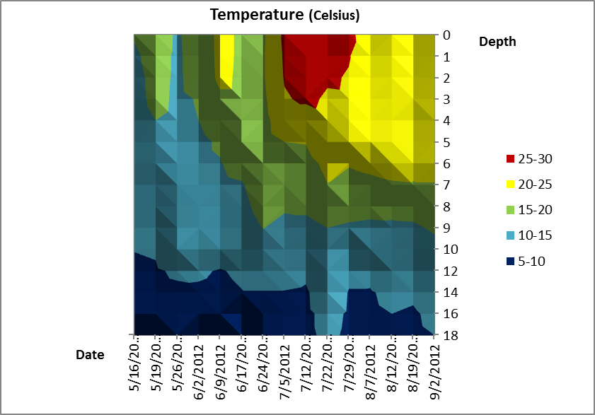
Figure 3. Temperature Profile 2012

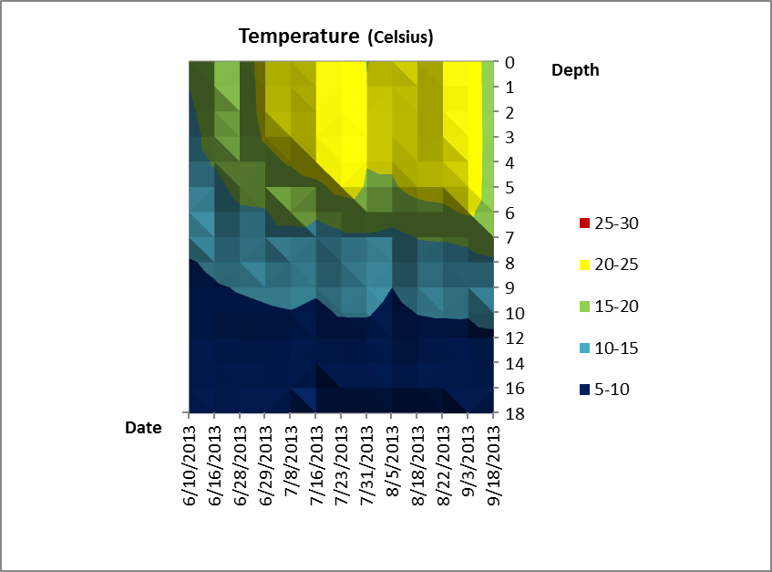
Figure 4. Temperature Profile 2013

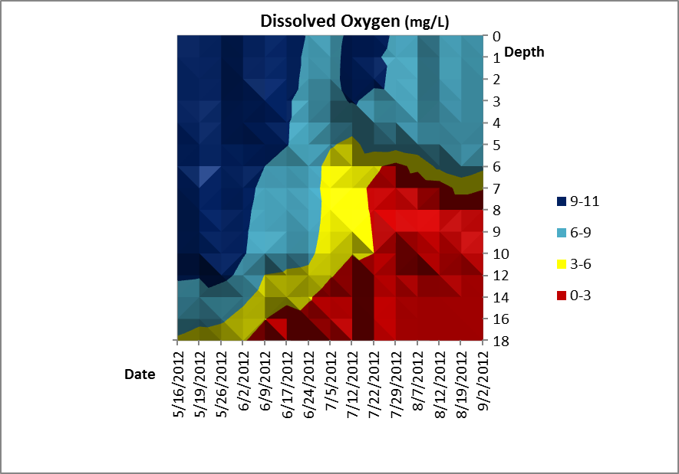
Figure 5. DO Profile 2012

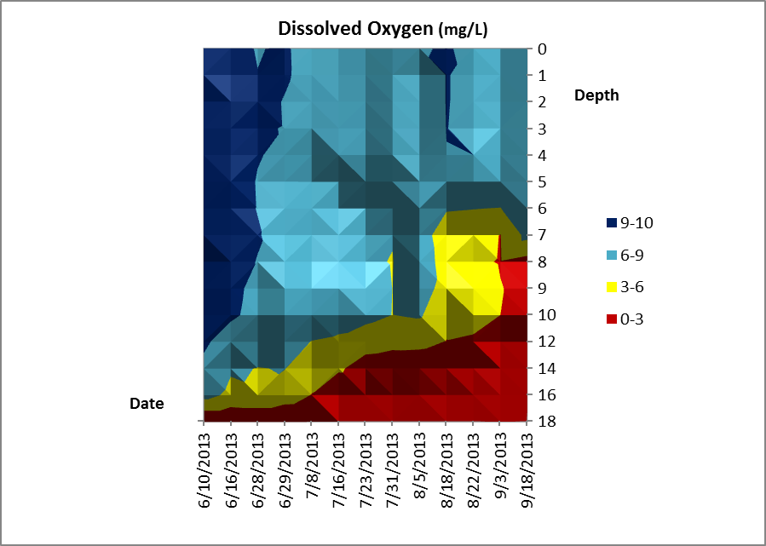
Figure 6. DO Profile 2013

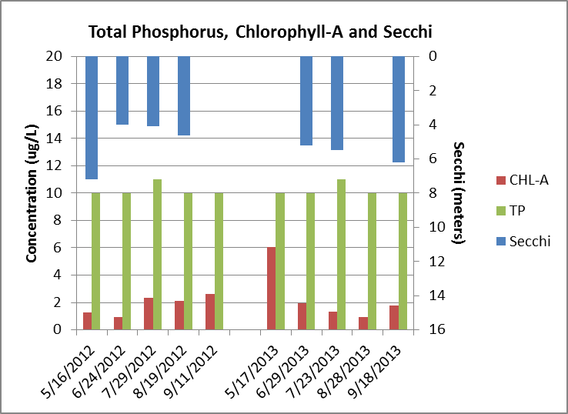Water Quality
Figure 7. Phosphorus, Chlorophyll-a & Secchi 2012 & 2013
Nutrients, typically phosphorus and nitrogen, are the primary drivers of algal productivity in lakes. In general, high nutrient levels increase the likelihood that nuisance algal blooms will grow and that lakes will not support aquatic recreational uses; however, there are other factors at play that also must be considered. For this reason, it’s important to collect information on water color, suspended solids, temperature, dissolved oxygen, and a number of other parameters. All May-September water chemistry data for Pike Lake gathered in 2012 and 2013 were averaged (referred to as “summer mean” values) and compared to minimally impacted reference lakes in the NLF ecoregion (Table 2). References lakes included in the last column in Table 2 include those selected to be typical of the ecoregion and minimally impacted, and allow for comparison to Pike Lake.

Table 2. Pike Lake 2012-2013 as compared to typical range for NLF ecoregion reference lakes
Parameter | Pike Lake 2012 | Pike Lake 2013 | Pike Lake 2-year summer mean values | Typical range for minimally impacted lakes in NLF
Number of reference lakes | 1 | 1 | 1 | 32
Total phosphorus (µg/L) | 10* | 10* | 10* | 14 – 27
Chlorophyll mean (µg/L) | 2 | 2 | 2 | 4 – 10
Transparency (feet)  (meters) | 17.0  5.2 | 20.7  6.3 | 19.0  5.8 | 8 – 15  2.4 – 4.6
Total Kjeldahl Nitrogen (mg/L) | 0.5 | 0.4 | 0.47 | 0.4 – 0.75
Alkalinity (mg/L) | 60 | 64 | 62 | 40 – 140
Chloride (mg/L) | 44 | 47 | 45.5 | 0.6 – 1.2
Total Suspended Solids (mg/L) | 1.6 | 1.3 | 1.48 | < 1 – 2
Total Suspended Inorganic Solids (mg/L) | 0.4 | 0 | 0.2 | < 1 – 2
TN:TP ratio | 50:1 | 50:1 | 50:1 | 25:1 – 35:1

Total phosphorus (TP) is often considered the nutrient that “limits” algal growth in lakes. This is because it is essential to algal growth and it is typically in the shortest supply. Pike Lake’s summer-mean TP is much better than typical range for NLF lakes (Table 2), with all but two samples collected within the surface sample area in 2012 and 2013 falling below the lab detection limit of 10 ug/L. Samples collected near the bottom of the lake had higher concentrations of phosphorus than surface readings, with bottom samples ranging from 13 ug/L to 55 ug/L. Bottom sample results were not included when calculating the summer mean results for Pike Lake, rather they were gathered to help gauge lake turnover (when the lake mixes, bottom and surface phosphorus readings are near equal) and determine the amount of phosphorus diffusing out of the sediment during anoxic conditions at the lake bottom during stratification.

For the purposes of summarizing the data for Pike Lake, all non-detect samples were rounded up to the lowest detectable limit for total phosphorus of 10 ug/L. Two readings were within the lab’s detectable limit, occurring in July 2012 and 2013. Both July readings were barely above the detectable limit at 11 ug/L, indicating that even during the hottest and driest time of the year, Pike Lake’s water quality is excellent.

Two previous water quality studies were conducted by the MPCA on Pike Lake in 1993 and 1999 and total phosphorus numbers have improved greatly since those earlier assessments (Figure 8). In 1993, mean summer TP was 18.4 ug/L and in 1999, mean summer TP was 19.2 ug/L, indicating that efforts to reduce phosphorus loading into Pike Lake have likely resulted in lower concentrations in the lake.
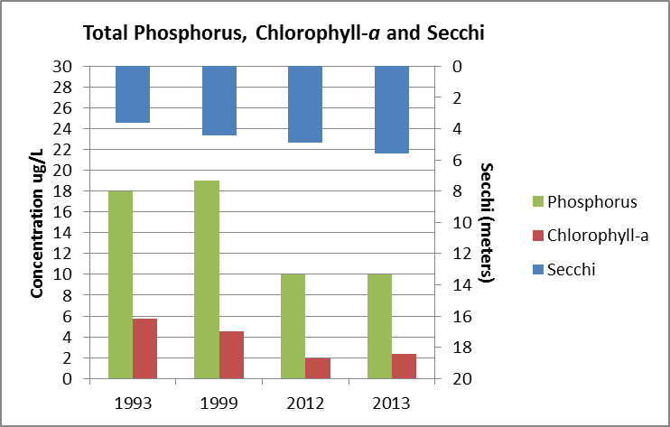
Figure 8. 1993, 1993, 2012 & 2013 Comparison for Site 102
Nitrogen, while also an essential nutrient for algal growth, is typically not the “limiting nutrient” in most Minnesota lakes. Total Kjeldahl nitrogen is a measure of organic nitrogen (i.e., nitrogen found in algae) and ammonia- nitrogen. When combined with inorganic nitrogen, this represents total nitrogen (TN). Since inorganic nitrogen is often at or below detection in lakes, we often use total Kjeldahl alone to represent TN. The ratio of TN to total phosphorus (TP) is used as a simple basis for discerning which nutrient, TN or TP, is the limiting nutrient. Lakes are often considered “nitrogen-limited” when the TN: TP ration falls below about 10:1. In the case of Pike Lake, its 50:1 ratio is very high, over the typical range for NLF lakes, indicating that phosphorus is the nutrient controlling algal growth in this lake. The addition of phosphorus to the lake could increase the production of algae and aquatic plants.

Chlorophyll-a (a pigment found in algae) is used to estimate the amount of algal production in a lake and, therefore, the lake’s response to nutrients. As would be anticipated with the low total phosphorus results found in Pike Lake, chlorophyll –a’s summer mean concentrations were also quite low. In fact, chlorophyll -a results were better than the expected range in every month of sampling except May 2013. The mean summer concentration of chlorophyll-a was 2 ug/L. With concentrations from 10-20 ug/L indicating a mild algal bloom and concentrations greater than 30 ug/L indicating severe nuisance conditions, an algal bloom on Pike Lake in 2012 or 2013 would have been a rare occurrence, if at all.
Chlorophyll-a results in 1993 and 1999 were 5.7 ug/L and 4.5 ug/L respectively (Figure 8). Efforts to reduce phosphorus in Pike Lake have greatly reduced the possibility for even mild algae blooms throughout the summer.
Secchi transparency measures the depth of water clarity and Pike Lake’s transparency readings were better than typical range for NLF lakes (Table 2) in both 2012 and 2013. Secchi transparency is directly influenced by the amount of algae in a lake and because of low chlorophyll -a and total phosphorus concentrations in Pike Lake, Secchi transparency would likely follow as being high. Another potential reason for increasing clarity levels in Pike Lake is the presence of zebra mussels, found in the lake in 2009. Zebra mussels have been known to increase lake clarity in just a few short years by filtering out large quantities of algae. The actual affect zebra mussels are having on Pike Lake is unknown, but as their numbers grow there is the potential for lake clarity to increase.
In some lakes, high total suspended sediment or high color may also limit transparency. High total suspended sediment may arise from suspended sediments (e.g. from runoff or wind mixing). In the case of Pike Lake, the total suspended sediment is within the typical range for NLF lakes.
Chloride (Cl) for Pike Lake was worse than the typical range for NLF lakes (Table 2). The primary source of Cl to Minnesota lakes is winter application of road de-icing (road salt) compounds; however, other potential sources include runoff from agricultural lands, water softeners, treated wastewater effluent, and seepage from septic systems. The 2012 and 2013 summer mean for Cl was 45.5 mg/L, increasing from a mean of 25.8 mg/L in 1999 and 20.7 mg/L in 1993. Cl will likely to continue to increase in the years to come since it is a conservative pollutant, meaning that it does not break down or leave the lake system over time. Without further examination of the potential sources it is difficult to say which one is the primary contributor for Pike Lake; however, the Cl concentration in the lake is far below the water quality standards so there is no immediate concern relative to adverse environmental impacts at these low concentrations.
CLMP+ data collected for Pike Lake shows that in terms of total phosphorus, chlorophyll and Secchi disk transparency, the water quality of the lake is equal to or better than minimally impacted (reference) lakes in the ecoregion. Moderately productive lakes such as Pike are termed ‘mesotrophic’.
Trends
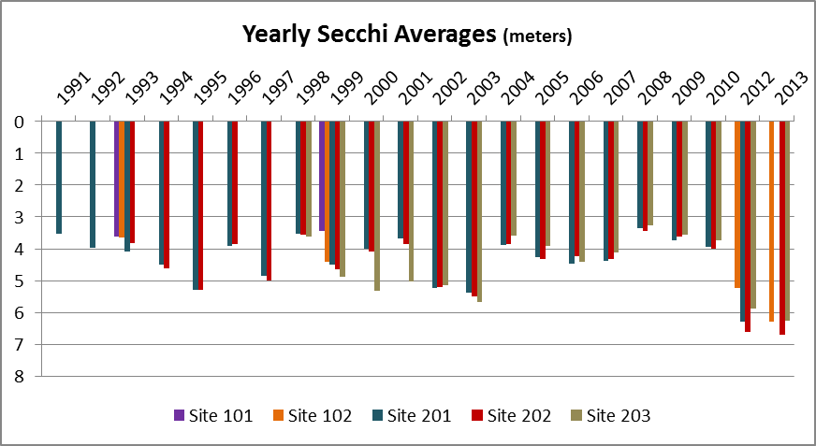As part of the CLMP, citizens have monitored multiple sites throughout Pike Lake for 22 years. The primary purpose of CLMP monitoring is to gather water clarity information for as many lakes as possible over a long period of time to determine if the water clarity trend for the lake over time is increasing, declining or remaining stable. At least 20 data points spread over eight years are required for a basic trend analysis, and more data are often needed to see an actual increasing or declining trend. Sufficient Secchi readings were collected on the Pike Lake between 1991 and 2013 to run the trend analysis (Figure 9); however, given the variability of the readings over these years, there is no evidence yet of a long-term trend in either direction. It is important to note that Secchi transparency for all CLMP monitoring sites in Pike Lake rose sharply in 2012 and 2013 (Figures 9 & 10). For the CLMP+ monitoring Site 102 in particular, the two -year mean transparency was 5.8 meters, compared to 3.64 meters in 1993 and 4.42 meters in 1999. Secchi transparencies averaged for the entire lake have also increased. In 1993, average Pike Lake Secchi transparency was 3.5 meters, in 2013 it was 6.4 meters (it is important to emphasize that 2012 and 2013 results are outliers in terms of averaged readings over the past 22 years). There is no indication that high transparency readings in 2012 and 2013 represent a long-term trend. However, continued participation in the CLMP program would help gather the data necessary to determine if an upward transparency trend exists.
Figure 9. Annual Secchi average for Pike Lake

Figure 10. Secchi readings 2012 & 2013

2 year mean

Summary

All of the water quality data from the MPCA’s monitoring activities, those of its citizen volunteers, and of other state and local partners are gathered together and used to assess the condition of Minnesota lakes by determining if thresholds set to protect a lake’s recreational uses (swimming, wading, boating, etc.) are being met. Annual assessments of lake and stream data are conducted on a rotating watershed basis. Pike Lake is located within the St. Louis River major watershed. In 2009, a selection of streams and lakes within this watershed were monitored as part of the MPCA’s intensive monitoring schedule. More information on the monitoring results and next steps for the watershed can be found here: http://www.pca.state.mn.us/index.php/water/water-types-and-programs/watersheds/st.-louis-river.html.
Based on water quality data collected as part of CLMP+ in 2012-2013, Pike Lake has very good water quality and appears to be fully meeting the thresholds set to protect lakes in the NLF ecoregion for aquatic recreation (Table 3).
Table 3. A comparison of water quality data from Pike Lake to the lake eutrophication standards for the NLF ecoregion
 | TP (µg/L) | Chl-a (µg/L) | Secchi (m)
Thresholds set to protect lakes in the NLF ecoregion for aquatic recreation use | <30 | <9 | >2.0
Pike Lake 2-year summer mean values | 10 | 2.0 | 5.8
Significant improvements in water quality have already been achieved for Pike Lake over the past decade, but continued engagement at the local level will be required to maintain the lake’s high level of water quality.
Recommendations:
- Continue to participate in the CLMP and regularly collect transparency data to provide the continuous water quality records needed for trend assessment.

- Continue to minimize as much as possible the potential for phosphorus to be routed, or loaded, to the lake. This entails limiting lakeshore development and retaining as much undeveloped land in the lake
catchment as possible.
- Engage with city and county officials to ensure protection of wetlands in the surrounding watershed. Wetlands trap and filter sediments and nutrients, limiting their eventual run-off into Pike Lake.
- Best management practices should be used when applying road deicers. Specifically, minimize the salting of roads near the lakes, and stockpile snow in upland areas away from the lakeshore. Pike Lake had chloride concentrations considerably higher than the ecoregion expectations. This is most likely due to “urban” runoff.
- Maintain native aquatic plant beds to support fishery habitat and the quality and balance of the fish community. Native aquatic plans also provide natural wave breaks and results in decreased shoreline erosion. Increased wave action stirs lake sediments, clouding the water, making it difficult for new plants to grow.
- Maintain remaining shoreline emergent aquatic vegetation – potentially important habitat for invertebrates and juvenile fish in addition to being a natural trap for washed in sediments and nutrients. Educate shoreland homeowners on the benefits of this habitat. The Minnesota Shoreland Management Guide (http://shorelandmanagement.org) provides useful information on this and other issues relevant to conserving the lake’s beneficial uses.

For questions regarding this report, please contact:
Shannon Martin
Citizen Monitoring Program
651-757-2874

Concentrations shown are the mean of samples taken May-September (i.e., summer means) ug/L = micrograms per liter; mg/L = milligrams per liter; Pt-Co-U = Platinum Cobalt Units * Several TP readings were below detectable lab limits. For the purposes of summarizing data, all non-detect samples were rounded up to the lowest detectable limit for phosphorus, which is 10 ug/L.
The phosphorus detection method used by the Minnesota Department of Health changed in 2012 and 2013, and phosphorus taken up by chlorophyll-a was not being included in final lab results, thereby potentially skewing readings slightly lower than they may actually be. The MPCA is working with MDH to change their phosphorus detection methods so they more accurately represent in-the-field findings, but it is something to keep in mind for the purposes of this report when reviewing phosphorus data.

